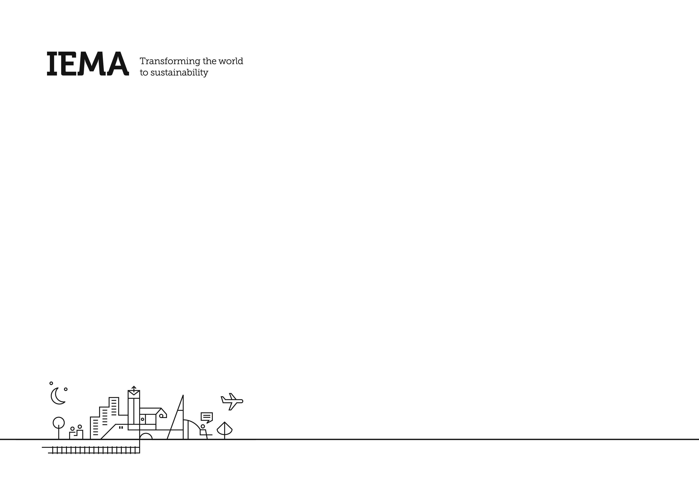

IEMA Membership Reinstatement

Continual Professional Development Record

**IEMA Membership Reinstatement CPD Record**

1. **Introduction**

|  |
| --- |
| In order to re-instate your IEMA Professional membership, you need to demonstrate how you have maintained your knowledge and skills relevant to your membership standard during the time away from the Institute. This is to be evidenced through completion of a CPD record either using our template below. |

CPD for reinstatement is a requirement for those who have held Professional Membership (Graduate, Associate, Practitioner, Full or Fellow) and/or a Specialist Register (Auditor, EIA Practitioner or ESOS Lead Assessor) with IEMA.

Note: You must evidence CPD for the entire period you have been away from IEMA. For example, if you have been away from IEMA for 24 months, you must provide evidence of CPD for this duration.

For each year away, it is recommended you evidence **30 hours** of CPD activity per annum.

**2. Completing your CPD Log**

A blank template is provided within this information pack.

Using the template provided, please detail CPD undertaken that links to the relevant membership standard (See IEMA’s Sustainability Skills Map [here](https://www.iema.net/sustainability-skills-map)).

1. **Next Steps**

Please ensure that all sections to the greatest degree of completeness possible and submit it info@iema.net.

Your submission will be reviewed by the Professional Standards Team to determine if your CPD meets the level of continued learning that aligns with your grade of membership, and to provide you with insights and suggestions as you move toward completing your goals.

**About you**

|  |  |  |  |  |  |  |
| --- | --- | --- | --- | --- | --- | --- |
| Name |  | Previous IEMA Membership Level | Choose an item. |  |  |  |
| Membership No. |  | Specialist Register (if applicable) | Choose an item. | Choose an item. | Choose an item. | Choose an item. |
| Email Address |  | | | | | |
| Job Title |  | Primary Work Area | Choose an item. |  |  |  |
| Location (if in the UK) | Choose an item. | Location (if outside the UK) |  |  |  |  |

**Evidence your Learning & Development**

Logging your learning gives you an opportunity to reflect on what you have gained, learned and achieved by doing your CPD activities. It also gives you the chance to think about how you can practically apply your new knowledge, and even stimulates what learning you’ll do next.

Remember professional development activities are not restricted to formal classroom training courses. You can do CPD at any time through day-to-day activities like reading, coaching and mentoring, experiential learning, networking, dialling into webinars, attending conferences and getting involved in research. Use the IEMA CPD Form to record each CPD activity you do. The form’s fields will prompt you to log the right details and help you reflect and evaluate on how each activity benefits your career.

|  |  |  |  |  |  |  |  |
| --- | --- | --- | --- | --- | --- | --- | --- |
| **Date** | Category | **Activity Description**  *Developing Yourself/Developing Others/Work Activities* | **Main Competency the activity relates to.** | **Level of work the activity relates to** | **Lessons Learnt**  *What have your learned from undertaking this activity?* | **Benefits Gained**  *What will you do differently? How has the activity benefitted your work practices?* | **No of Hours** |
| Click or tap to enter a date. | Choose an item. |  | Choose an item. | Choose an item. |  |  |  |
| Click or tap to enter a date. | Choose an item. |  | Choose an item. | Choose an item. |  |  |  |
| Click or tap to enter a date. | Choose an item. |  | Choose an item. | Choose an item. |  |  |  |
| Click or tap to enter a date. | Choose an item. |  | Choose an item. | Choose an item. |  |  |  |
| Click or tap to enter a date. | Choose an item. |  | Choose an item. | Choose an item. |  |  |  |
| Click or tap to enter a date. | Choose an item. |  | Choose an item. | Choose an item. |  |  |  |
| Click or tap to enter a date. | Choose an item. |  | Choose an item. | Choose an item. |  |  |  |
| Click or tap to enter a date. | Choose an item. |  | Choose an item. | Choose an item. |  |  |  |
| Click or tap to enter a date. | Choose an item. |  | Choose an item. | Choose an item. |  |  |  |
| Click or tap to enter a date. | Choose an item. |  | Choose an item. | Choose an item. |  |  |  |
| Click or tap to enter a date. | Choose an item. |  | Choose an item. | Choose an item. |  |  |  |
| Click or tap to enter a date. | Choose an item. |  | Choose an item. | Choose an item. |  |  |  |
| Click or tap to enter a date. | Choose an item. |  | Choose an item. | Choose an item. |  |  |  |
| Click or tap to enter a date. | Choose an item. |  | Choose an item. | Choose an item. |  |  |  |
|  |  |  |  |  |  | **Total Number of Hours** |  |

**(Specialist Registers only)**

For Specialist Registers only, use this section to list the relevant work you have been doing as it relates to your Specialist Register membership.

|  |  |  |  |  |  |
| --- | --- | --- | --- | --- | --- |
| **Date(s) work was undertaken** | **Number of days onsite**  Numeric, i.e. 1, 2, 3 | **Number of days offsite**  Numeric, i.e. 1, 2, 3 | **Role in Project/Audit**   * **L** = Lead Auditor, Sole Auditor * **A** = Auditor; under supervision of Lead Auditor * **TP** = Training Provider * **PM** = Project Manager * **O** = Other | **Activity Description**   * CPD activity * ESOS competency (where applicable) * Training received * Training provided | **Verification source of third party, e.g. client, site contact**   * Name * Address * Phone, email, fax |
| *Example:*  *20-21 June 2017* | *2* | *1* | *L* | *Conducted a full Initial Environmental Review of a garage.* | *Name of individual, company, address, phone, email, fax* |
|  |  |  | Choose an item. |  |  |
|  |  |  | Choose an item. |  |  |
|  |  |  | Choose an item. |  |  |

The information I have provided is a true and accurate record of my Continuing Professional Development (CPD)

|  |  |
| --- | --- |
| Name: | Date: |